**Software Testing Assignment**

**Module–1(Fundamental)**

**• What is SDLC**

**SDLC Stand for SOFTWARE DEVELOPMENT LIFE CYCLE .** **The Software Development Life Cycle (SDLC) is a structured process that helps developers create software. It's also known as the software development process.**

**There are six stages of SDLC**

**1)Requirement Gathering**

**2)Analysis**

**3)Design**

**4)Implementation->Coding**

**5)Testing**

**6)Maintenance**

**• What is software testing?**

**Testing is a process used to identify correctness,completeness and quality of developed computer software.**

**testing is executing a system in order to identify any gaps, errors or missing requirements in contrary to the actual desire or requirements.**

**• What is agile methodology?**

**Agile SDLC model is a combination of iterative and incremental process models.**

**It is the latest model used by major companies today like Facebook, google, amazon, etc.**

**This module used to long term project .**

**• What is SRS**

**A software requirements specification (SRS) is a complete description of the behavior of the system to be developed.**

**Types of Requirements :**

**1:-Customer Requirements**

**2:-Functional Requirements**

**3:-Non-Functional Requirements**

**• What is oops**

**OOP stands for Object Oriented Programming.**

**An object is like a black box.**

**The internal details are hidden.**

**• Write Basic Concepts of oops**

**1:-Object**

**2:- Class**

**3:-Encapsulation**

**4:-Inheritance**

**5:- Polymorphism**

**1:-Overriding**

**2:-Overloading**

**6:-Abstraction**

**• What is object**

**Any entity which has an own state and behavior.**

**ex: university, a city, a country etc..**

**• What is class**

**collection of objects**

**ex: human body**

**• What is encapsulation**

**wrapping up of data or binding of data**

**ex:capsule**

**• What is inheritance**

**When one object acquire all the properties and behaviour of parent class**

**ex:father – son**

**• What is polymorphism**

**Many ways to perform anything**

**1. Method Overloading**

**2. Method Overriding**

**• Write SDLC phases with basic introduction**

**1:Requirement Gathering:-fullfill the requirement of client.**

**Types of Requirements:**

**1. Functional Requirements:-Any changes will do.**

**2. Non-Functional Requirements:-No changes.**

**2: Analysis Phase:-** **This analysis represents the “what” and “how” phase.**

**3:Design:**  **In this phase, the software design is created.**

**4:Implementation: The design is then implemented in code.**

**5:Testing:** **After successful testing**

**6:Maintainance: This phase includes ongoing support, bug fixes, and updates to the software.**

**1-Corrective maintenance: identifying and repairing defects.**

**2-Adaptive maintenance: adapting the existing solution to the new platforms.**

**3-Perfective Maintenance: implementing the new requirements.**

**• Explain Phases of the waterfall model**

**Requirements are very well documented, clear and fixed.**

**The project is short.**

**Product definition is stable.**

**It is very simple to understand and use.**

**In a waterfall model, each phase must be completed before the next phase can begin and there is no overlapping in the phases.**

**1:Requirement Gathering:-fullfill the requirement of client.**

**2: Analysis Phase:-** **This analysis represents the “what” and “how” phase.**

**3:Design:**  **In this phase, the software design is created.**

**4:Implementation: The design is then implemented in code.**

**5:Testing:** **After successful testing**

**6:Maintainance: This phase includes ongoing support, bug fixes, and updates to the software.**

**1-Corrective maintenance: identifying and repairing defects.**

**2-Adaptive maintenance: adapting the existing solution to the new platforms.**

**3-Perfective Maintenance: implementing the new requirements.**

**• Write phases of spiral model**

**The Spiral Model is one of the most important**[**Software Development Life Cycle models**](https://www.geeksforgeeks.org/top-8-software-development-models-used-in-industry/)**.**

**The Spiral Model is a combination of the waterfall model and the iterative model. It provides support for Risk Handling.**

**The Spiral Model was first proposed by Barry Boehm.**

**For medium to high-risk projects**

**Customer is not sure of their requirements which are usually the case.**

**• Explain working methodology of agile model and also write pros and cons.**

**Agile SDLC model is a combination of iterative and incremental process models.**

**Agile Methods break the product into small incremental builds.**

**Every iteration involves cross functional teams working simultaneously on various areas like planning, requirements analysis, design, coding, unit testing, and acceptance testing.**

**Pros:-**

**Little or no planning required**

**Easy to manage**

**Gives flexibility to developers**

**Promotes teamwork and cross training**.

**Cons:-**

**Not suitable for handling complex dependencies.**

**More risk of sustainability, maintainability and extensibility.**

**• Draw Usecase on Online book shopping**

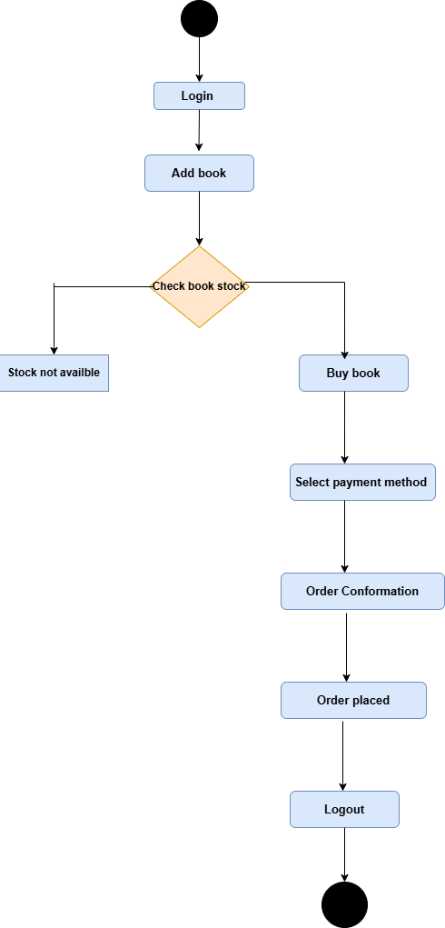

**• Draw Usecase on online bill payment system (paytm)**

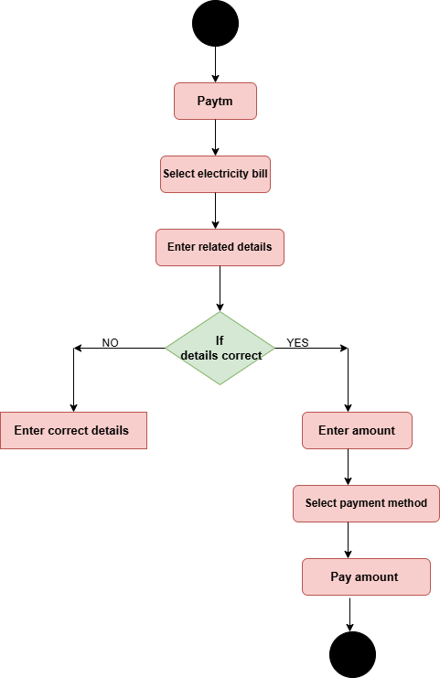

**• Draw usecase on Online shopping product using COD.**

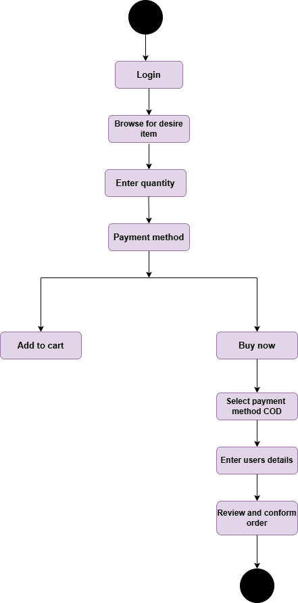

**• Draw usecase on Online shopping product using payment gateway.**

